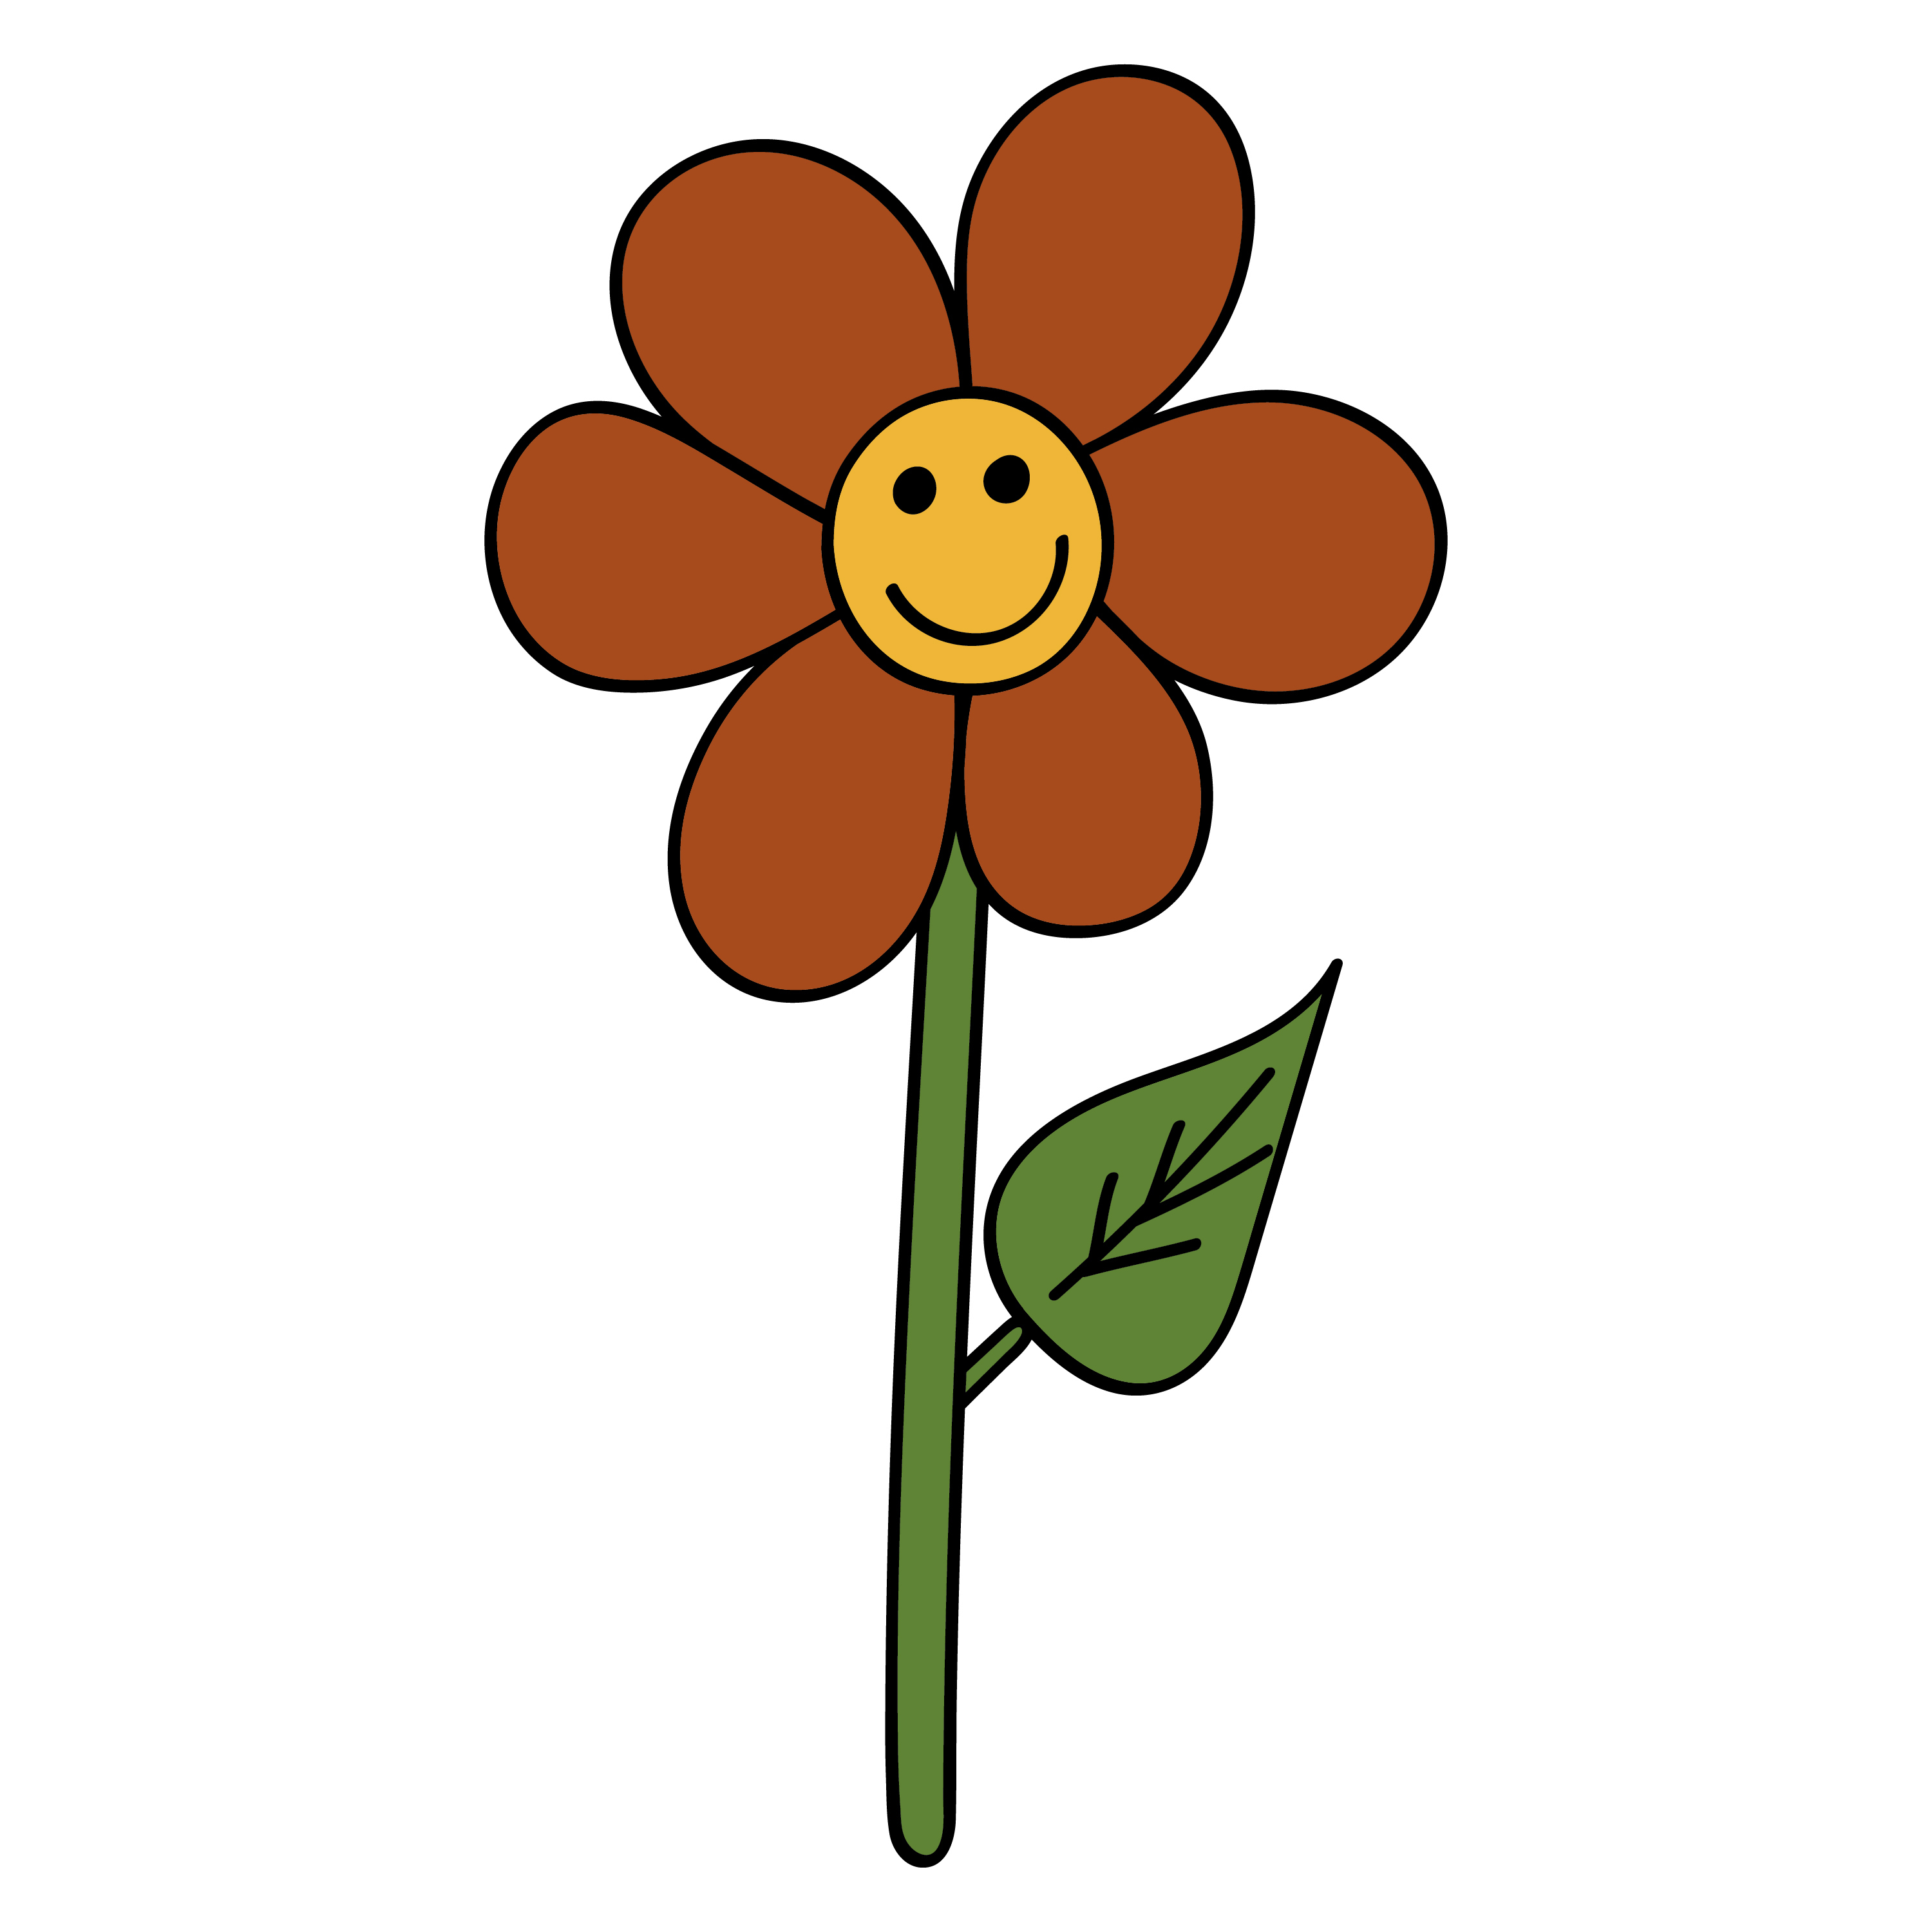

We are making friendship flowers in class that display all the reasons we are good friends.

Please write one of my qualities that makes me a good friend on each leaf so I can add it to my flower.

I can colour and cut them out afterwards.

e.g.

I check someone is ok if they look sad.

I take turns when playing games.