Dear Parents/Carers
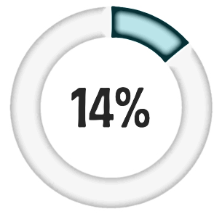
Many parents expect that their children will come to them if they have questions about relationships and sex, but in a recent survey of WA teens, only:
felt
confident or very confident
to talk to their
dads
(or male guardians)
about sex
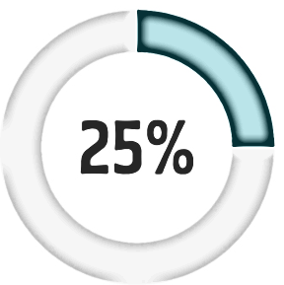
felt
confident or very confident
to talk to their
mums
(or female guardians)
about sex

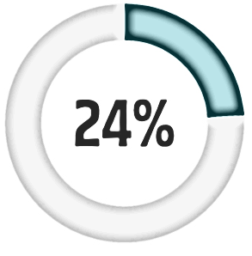
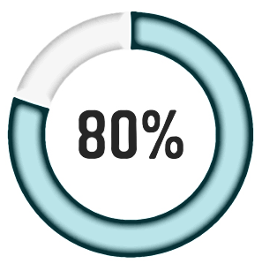
have a high level of
trust
in the
internet
for advice
about sexual health¹
have ever used the
internet
for advice
about sexual health

It is very important that young people (and adults) use reliable Western Australian and Australian websites to answer health questions rather than doing an internet search.
Here are some reliable Western Australian and Australian websites. This is not an exhaustive list.

getthefacts.health.wa.gov.au

Get the Facts is a WA Department of Health website for 13-17 year olds. It has an ask a confidential ‘ask a question’ feature where young people can submit questions that are answered by a qualified health professional.

Respectful relationships
kidshelpline.com.au/teens
theline.org.au

Sexual assault
kemh.health.wa.gov.au/SARC

Staying safe
kidshelpline.com.au/young-adults/issues/why-you-need-know-about-safe-sex .au/young- headspace.org.au/explore-topics/for-young-people/sex-and-sexual-health/

Help seeking
kidshelpline.com.au

Legal issues
resources.legalaid.wa.gov.au/project/rulegal/packs/sex-consent/consent
yla.org.au

