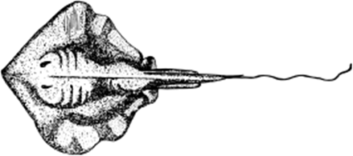
Stingray (Aggressive)

Is a bad way to disagree because you hurt others to get what you want even if it’s not fair. You are only interested in winning.

Jellyfish (Passive)

Is a bad way to disagree because you are a bit wishy-washy. You don’t stand up for what you want because you are frightened or want to stay friends. You give in or pretend that there is no problem.

Starfish (Assertive)

Is a good way to disagree because you sort things out in a fair and friendly way so that both sides can win.

You speak up in a calm way

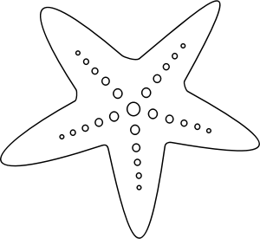
You say what you feel and what you want

You say sorry if you are wrong

You ask the other person what they feel

You ask the other person what they want

You ask for help if you both can’t sort it out

I mostly deal with disagreements the ______________________way.

The Starfish skill I would most like to practise is ________________________________________

______________________________________________________________________________

