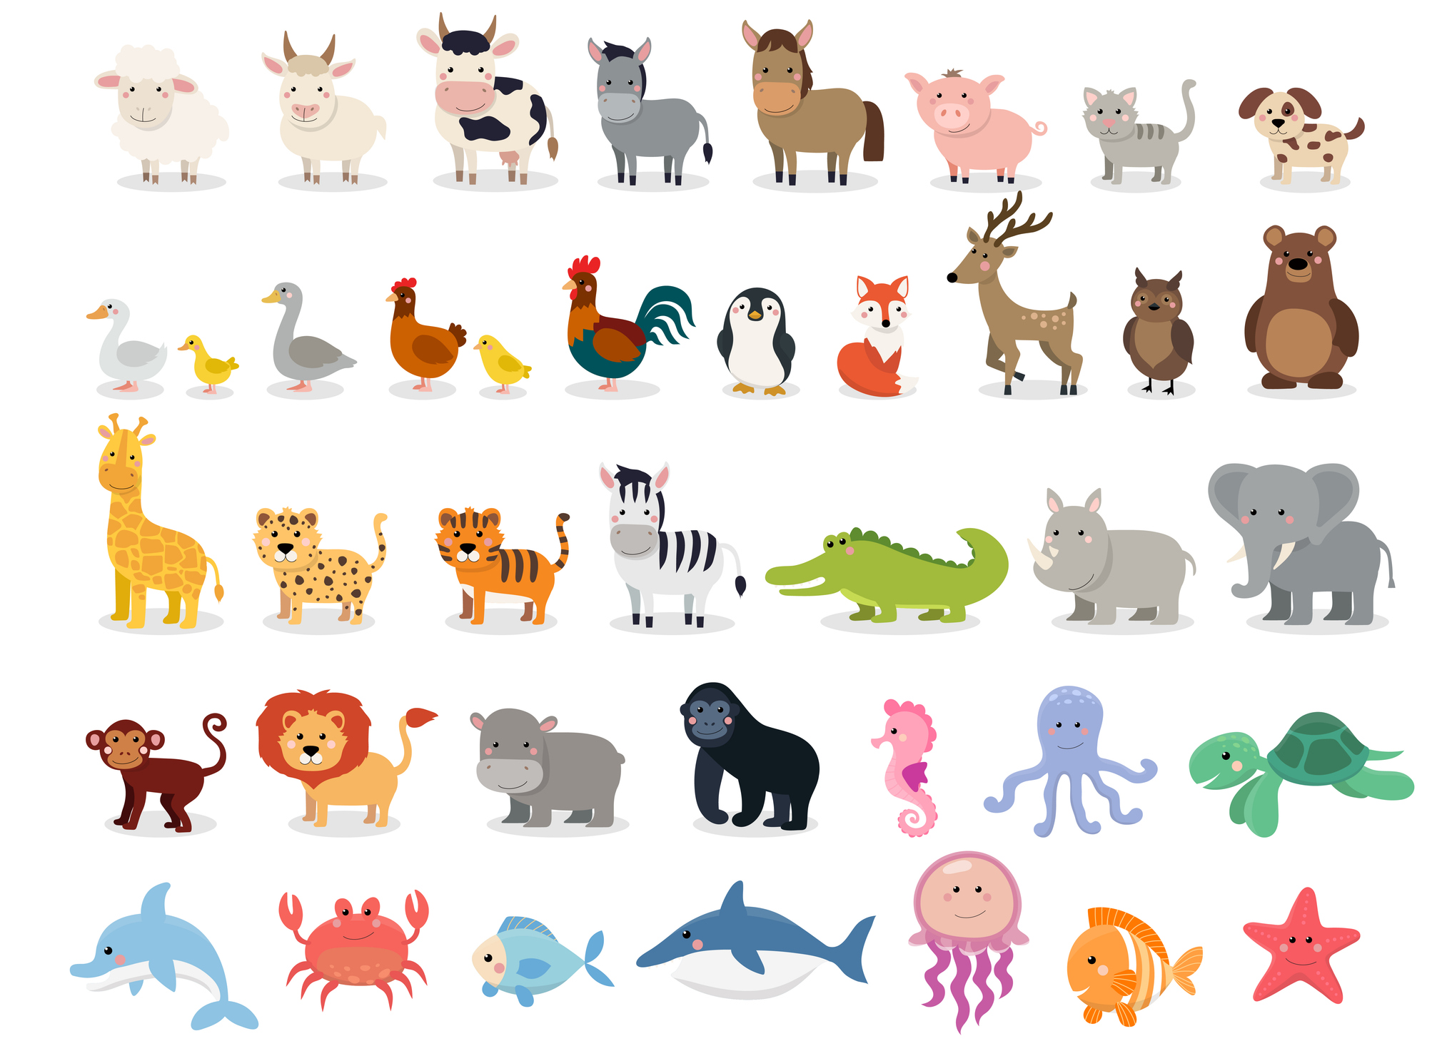

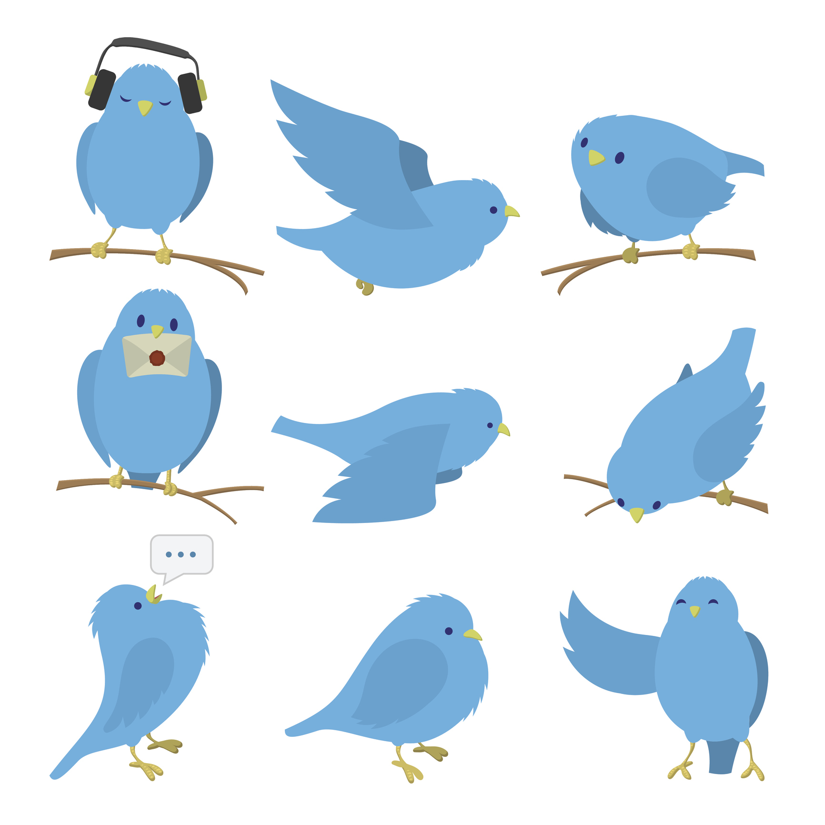

fish

jellyfish

lion

cow

donkey

cheetah

giraffe

monkey

bird

elephant

rhinoceros

crocodile